COMMENTS / NOTES

Functionality to be implemented for R4A: For meter installation type ‘08’ (Multi-function Meter {MFM} with power factor), legacy meters will require KWH, max KW and Power Factor (PF) registers to be read. The Smart meter equivalent will require KWH, max KW and KVARH registers to be read because Smart meters are not capable of recording avg. PF. The OMAR change is to display both KVARH and PF registers for installation type ‘08’. The meter field employee will populate what’s available (PF for legacy, and KVARH for Smart meter), and mark an X to the field that’s not available. OMAR has the ability to bypass the index read having an ‘X’.
Screen Description / Process Flow

STEP 1 – Electric Meter Completion Screen for a Poly Phase Smart meter
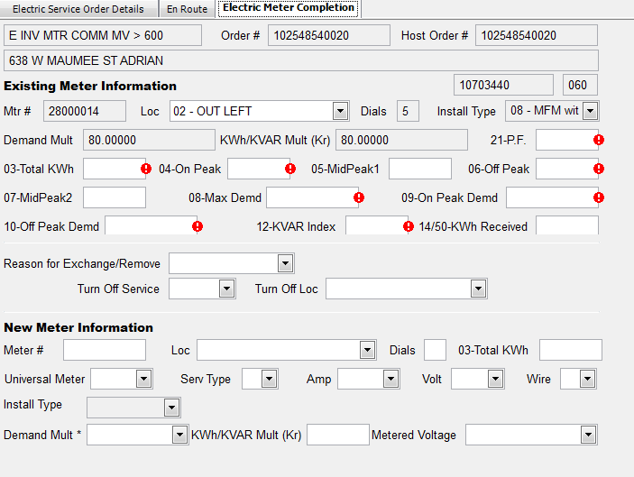
- 12-KVAR Index = KVARH
STEP 2 – Electric Maintenance Completion Screen for a Poly Phase Smart Meter
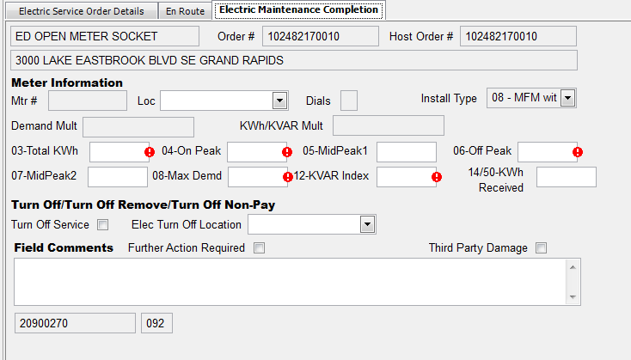
- 12-KVAR Index = KVARH

STEP 3 – Additional Information
- The KVARH index on the ‘to be installed’ Smart meters will be set/reset to ‘0’ when they leave the meter shop. There should be no instance where the read is not set to zero. If this is encountered, the field employee should not install the meter.

- Note: Order completion interface from OMAR to SAP does not support ON index read for KVARH and it was determined that it is not required with the above procedure in place.

